ANN Architecture Documentation

Purpose
This document specifies the architecture of the Artificial Neural Network (ANN) used to predict customer churn, built in PyTorch. It covers the input, hidden, and output layers, the design choices behind them, and the training configuration used to optimise the model.

Input Layer
- 10 input features, matching the prepared dataset from Stage 2: gender, SeniorCitizen, Dependents, tenure, PhoneService, MultipleLines, InternetService, MonthlyCharges, Contract_One year, Contract_Two year
- tenure and MonthlyCharges are standardized (mean 0, standard deviation 1) using the same StandardScaler fit in Stage 2; all other features are already binary (0/1).

Hidden Layers
Layer | Type | Size | Activation | Regularisation
Hidden 1 | Fully connected (nn.Linear) | 16 neurons | ReLU | Dropout (p = 0.3)
Hidden 2 | Fully connected (nn.Linear) | 8 neurons | ReLU | Dropout (p = 0.2)

Design reasoning
- A 2-layer, narrow network (16 → 8 neurons) was chosen because the problem has only 10 tabular input features — not image or text data — so a small number of layers is enough to model the relationships without unnecessary complexity.
- ReLU activation is used in both hidden layers because it trains faster and avoids the vanishing-gradient problems associated with sigmoid/tanh in hidden layers.
- Dropout (randomly disabling 20–30% of neurons during training) is included specifically to reduce overfitting, since the dataset is relatively small (~5,600 training rows) and the churn classes are imbalanced.

Output Layer
- 1 neuron, Sigmoid activation.
- Outputs a single probability between 0 and 1, representing the predicted likelihood that a customer churns.
- A threshold of 0.5 is used to convert this probability into a final Yes/No churn prediction.

Full Architecture Summary
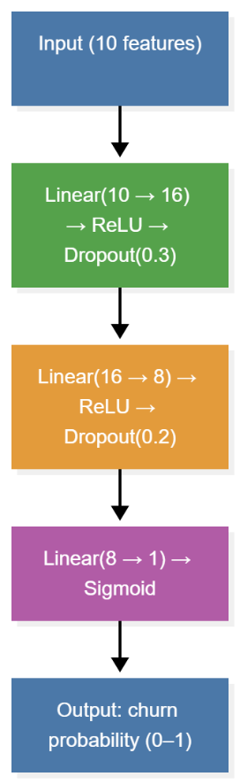
Figure 1: Architecture Diagram

Code
import torch.nn as nn

class ChurnANN(nn.Module):
def __init__(self, n_features):
super().__init__()
self.network = nn.Sequential(
nn.Linear(n_features, 16),
nn.ReLU(),
nn.Dropout(0.3),
nn.Linear(16, 8),
nn.ReLU(),
nn.Dropout(0.2),
nn.Linear(8, 1),
nn.Sigmoid()
)

def forward(self, x):
return self.network(x)

Training Configuration
Setting | Value | Reasoning
Loss function | Binary Cross-Entropy (BCELoss) | Standard loss for binary classification problems
Optimizer | Adam, learning rate = 0.001 | Adapts the learning rate automatically; converges reliably on tabular data
Batch size | 32 | Small enough for stable gradient updates on this dataset size
Max epochs | 100 | Upper bound; early stopping ends training sooner in practice
Early stopping | Patience = 10 epochs, monitoring validation loss | Prevents overfitting and stops training once further epochs stop helping
Validation split | 20% of the training set | Used only for early stopping, kept separate from the final test set

Actual Training Outcome
- Training stopped automatically via early stopping at epoch 55 (out of a maximum of 100).
- Best validation loss achieved: 0.4695.

Why This Architecture Over Alternatives
- A single-layer network was considered too simple to capture interactions between features (e.g., tenure combined with contract type).
- A much deeper network (4+ hidden layers) was avoided, since the dataset is small and tabular — a larger network would be more prone to overfitting without a meaningful accuracy gain.
- Dropout was chosen over L2 regularisation alone because it is simple to implement in PyTorch and performed well in practice, as shown by the close alignment between training and validation accuracy during training.

